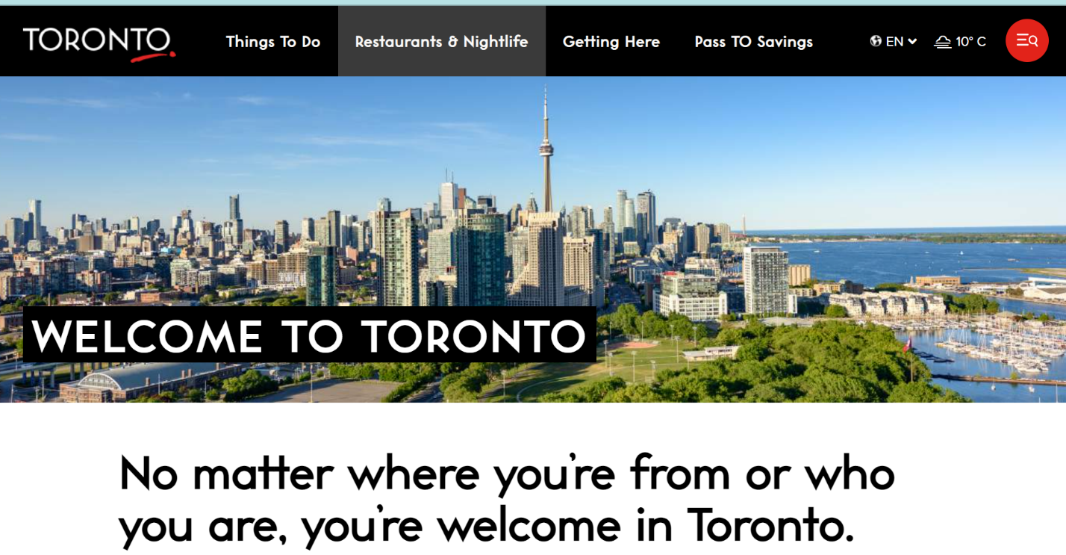

https://www.destinationtoronto.com/delegate-microsite/

For a more immersive-experience, check out this site featuring rich content from photography, video, attractions, dining and nightlife your attendees can expect when here in Toronto.
The microsite will also link to Pass TO Savings - a free, mobile passport that features exclusive offers on attractions and entertainment for all.

