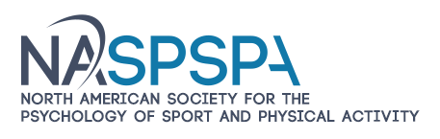
PROMTE YOUR BUSINESS
Be a sponsor for the
2023 Annual Meeting of the North American Society for the Psychology of Sport and Physical Activity

June 1 to 3, Toronto

Visit NASPSPA at www.naspspa.com

Your business has either supported NASPSPA in the past or has been identified as one that may have great appeal to NASPSPA members. We realize times have changed but we wanted to offer a great opportunity for your business to be a sponsor for the NASPSPA program in June of 2023. Being a sponsor is a great way to effectively promote your own business with NASPSPA members.

The North American Society for the Psychology of Sport and Physical Activity is a multidisciplinary association of scholars from the behavioral sciences and related professions. The Society functions to:
- Develop and advance practice through the scientific study of human behavior when individuals are engaged in sport and physical activity.
- Facilitate the dissemination of information.
- Improve the quality of research, teaching, and practice in the psychology of sport, motor development, and motor learning and control.
We typically have 500 to 600 participants attending our annual meeting and our hotel sold out in two days last June. We also have an overflow hotel. Individuals include many of the top scientists in the fields represented which includes motor learning/control, motor development, and sport and exercise psychology. NASPSPA also has a strong contingent of students who will become faculty at universities and require new equipment to conduct their research and textbooks for their classes.
For the last two years we held virtual meetings. In 2022 we met face to face and Hawaii and had great attendance from our members.
Please let me know if you have any questions. YOU CAN PAY THROUGH PAYPAL USING YOUR BANK ACCOUNT OR CREDIT CARD. I can send you the link.
Please contact me via email and let me know of your decision.
We look forward to working with you to maximize your investment of time and service to our organization.
Penny McCullagh, Ph.D., Executive Director naspspaed@gmail.com 415-225-7754

Sponsorship options include:
Option 1 Option 2 Option 3
Pre Event $500 $1000 $2000
Sponsor a named Keynote Lecture –
- 4 lecturers x
Senior Lecture – 3 opportunities x
Social Media Promotion x x x
Access to Conference- one Comp Reg x x
Recognition at conference x x x
Booth at conference or materials displayed x x
Student Support and recognition x x x
Post Conference
Logo on Website for One Year x x

