Take the UP Express Train from Pearson airport
- Takes 25 minutes from airport
- Cab fare is about $60
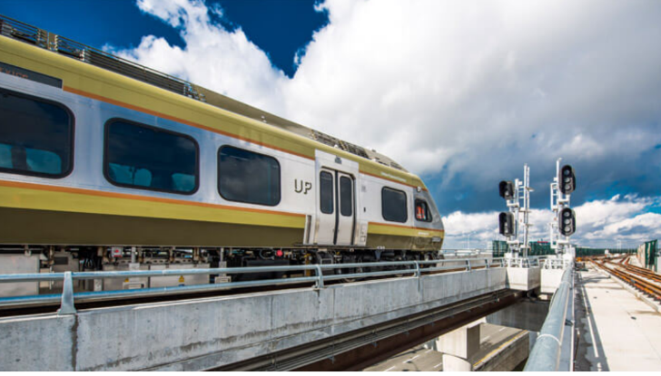
- Train arrives Union Station which is 10 to 15 min walk to Hilton on Richmond. Go to this site to purchase tickets. www.upexpress.com and use code Naspspa23. Code will be good until early June so lots of time to use it pre event and post if they stay a bit however tickets once bought are good for a year. Discount is 25% off. $12.35 one way goes now to $9.26.

https://www.upexpress.com/public/UP-Express-Terminal-1-Directions-Web.pdf
https://www.upexpress.com/public/UP-Express-Terminal-3-Directions-Web.pdf

file:///C:/Users/Penny/Dropbox%20(Personal)/PC/Downloads/UP_BusinessTravel_EN_Final_Oct26-2022%20(2).pdf

