Via Rail
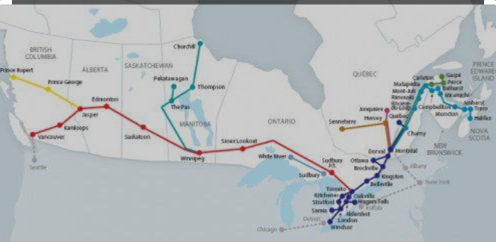
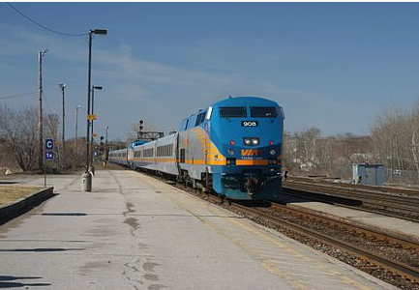

This will confirm VIA Rail Canada’s participation as a major ground transportation company for your
“Annual conference NASPSPA”

We are pleased to be a participant and would like to thank you for including VIA Rail Canada.

The following are the details pertaining to your conference fare:

VALID: | May 28th 2023 to June 7th 2023
TERRITORY: | From all stations throughout the VIA system to Toronto, Ontario and return.
RESTRICTIONS: | Fare applies to a maximum of two passengers per booking.  One complimentary stopover is allowed at no additional charge.  For travel on all fare plans in Business class, the first stopover is allowed at no additional charge, provided that this stopover takes place in Toronto, Montréal or Ottawa only.
DISCOUNT: | 10% off the best available fare in Economy, Economy Plus, Business, Business Plus, Sleeper class. "Subject to the conditions and restrictions of the fare plan to which the additional discount is being applied."
EXCEPTION: | Discount does not apply in any Escape fares and Prestige Class.
IDENTIFICATION: | Participants must reference the event’s VIA convention discount code: 14334.

