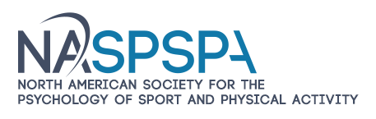
PROMOTE YOUR UNIVERSITY AND RECRUIT THE BEST
FACULTY, POST DOCS, AND GRADUATE STUDENTS FOR YOUR PROGRAMS!

2024 Annual Meeting of the North American Society for the Psychology of Sport and Physical Activity
June 5 to 8, 2024 New Orleans
Visit NASPSPA at www.naspspa.com

Your department has had many active members in the North American Society for the Psychology of Sport and Physical Activity (NASPSPA) over the years, who have benefitted from the many services and professional development opportunities our organization has to offer. NASPSPA has provided its members an avenue to share, collaborate, and advance our scholarly work for years.

NASPSPA is offering a great opportunity for your university to be a exhibitor for the NASPSPA program in June of 2024. Being a exhibitor will bring visibility and promote your program to NASPSPA members and help recruit outstanding faculty and students. We think the opportunities for sponsorship of our keynotes and senior lecturer sessions, and support for student members is especially attractive for universities.

NASPSPA is a multidisciplinary association of scholars from the behavioral sciences and related professions. The Society functions to:
- Develop and advance practice through the scientific study of human behavior when individuals are engaged in sport, physical activity and many other goal-directed pursuits
- Facilitate the dissemination of information
- Improve the quality of research, teaching, and practice in the psychology of sport, motor development, and motor learning and control.
We typically have 500 to 600 participants attending our annual meeting. Individuals include many of the top scientists in the fields represented, which includes motor learning and control, motor development, and sport and exercise psychology. NASPSPA also has a strong contingent of students who are looking for graduate programs or careers. You can review the varying levels of support in the document - Conference Exhibitor/ Sponsorship Package.
YOU CAN PAY THROUGH PAY PAL USING YOUR BANK ACCOUNT OR CREDIT CARD. Please let me know if you have any questions. Or contact me via email if you are ready to sign up. I will send you the link for payment.
We look forward to working with you to maximize your investment of time and service to our organization. Click on the NASPSPA Sponsorships Packages on the web under Annual Conference 2024.
Penny McCullagh, Ph.D., Executive Director naspspaed@gmail.com 415-225-775

